Research objective:
- How has mortality rate has changed in Uzbekistan between 1990 – 2019?
- What is the average number for each category of death cause?
- Comparative analysis of mortality rate between Uzbekistan, France and Niger
Introduction
As a graduate of economics and public policy, I have developed profound interest in how policies shape and affect daily life of people, improve their standard of living and well being in many ways. Even though there are dozens of interesting areas of policies, I have a particular interest in health policy, which I consider as essential and highly responsible field, directly affecting people’s lives. Therefore, I’m planning to specialize in this, in heath policy analyst position to be specific and working on some very useful analysis projects. In this analysis, I decided to focus on turning and interesting raw data into useful advice as a policymaker. The focus is on Uzbekistan, in other words, how number of deaths and their causes has been changing in this country over the last 30 years.
Method
To analyze the trend of mortality in Uzbekistan, I chose python language (panda library) as the most helpful and efficient way of turning raw data into actionable insights for policymakers. First of all, I loaded a data set names “annual number of death by cause” from official page of Kaggle. The data set provides information about number of deaths in the countries for 1990–2019-year periods and corresponding factors of deaths, such as types of diseases, violations, accidents, political executions and etc. Subsequently, I conducted comparative analysis also with France and Niger to compare the cases in different continents. Below I provide information on how each step of analysis was done and the whole detailed coding script is available at my GitHub account.
Analysis & Results
Initially, I tried to clean and filter the dataset to remove missing values, however, it resulted in removing a significant number of rows from the data frame, including all rows of Uzbekistan, which was the target country. For this reason, I then decided not to conduct the cleaning and filtering stage at this point. In the next stage, I filtered the dataset specifically for Uzbekistan and filtered columns starting only with “Deaths – …” to make sure only causes of deaths are included in analysis rather than identifiers, such as year, country abbreviations or full names. Following this, sum of each death factor has been calculated for all years between 1990 – 2019 to find out which type of disease caused the most of the deaths and the top 5 causes of death has been sorted in descending order. It has then become clear that ‘Cardiovascular’ diseases were the main cause of death, killing nearly 3,000,000 people for all the given period. The trend had the same figures for average ratings of mortality. In the following step included performing operation for identifying the trend over the years, in other words, how the mortality rate has changed over the years 1990-2019. Finally, by using matplotlib library, I plotted the line graph to visualize only the top 5 causes of death in Uzbekistan over the given period. 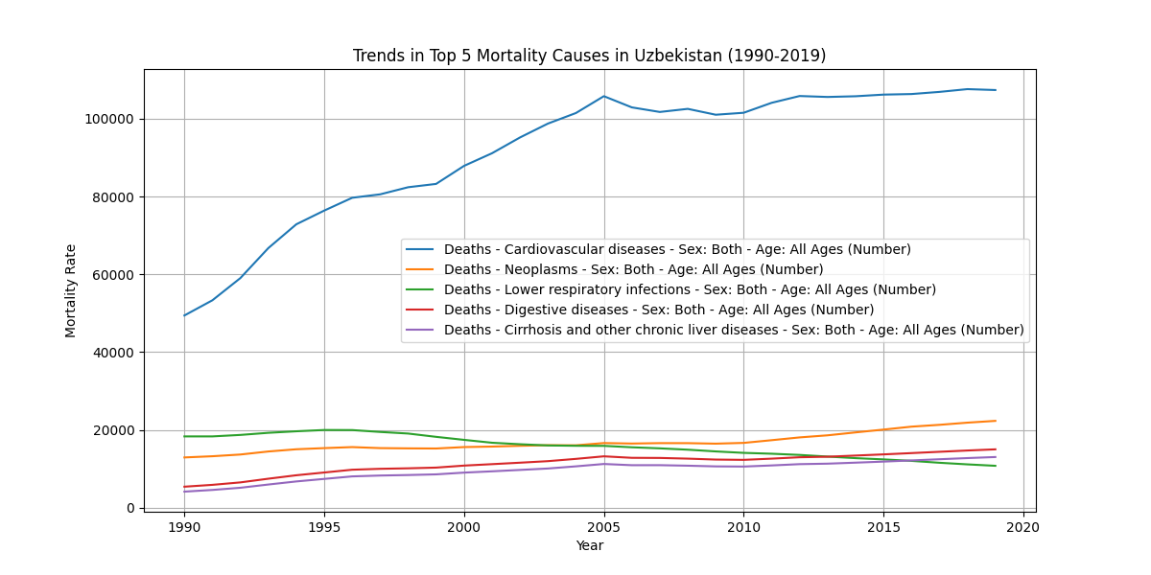
As can be seen in the graph, the number of people dying from cardiovascular diseases have been significantly higher than throughout the period. If in 1990s, the mortality rate was around 50000 people, this figure had doubled by 2005 and continued a stable increase, while remaining top 4 causes levelled up around 20000 for the given period. It is important note, however, that this may not be an fair result owing to demographic shifts. In other words, population of Uzbekistan has also increased dramatically over the years corresponding to mortality rate. Therefore, it may be better to, for example, calculate mortality rate per 100 people to ensure more fair results.
Moreover, comparative analysis with France and Niger was conducted to see how the case is different European and African continent. Firstly, each of the country was filtered from data frame name and time period. Then, with a similar method, another line graph was plotted showing the three different countries only for one type of disease – cardiovascular disease.
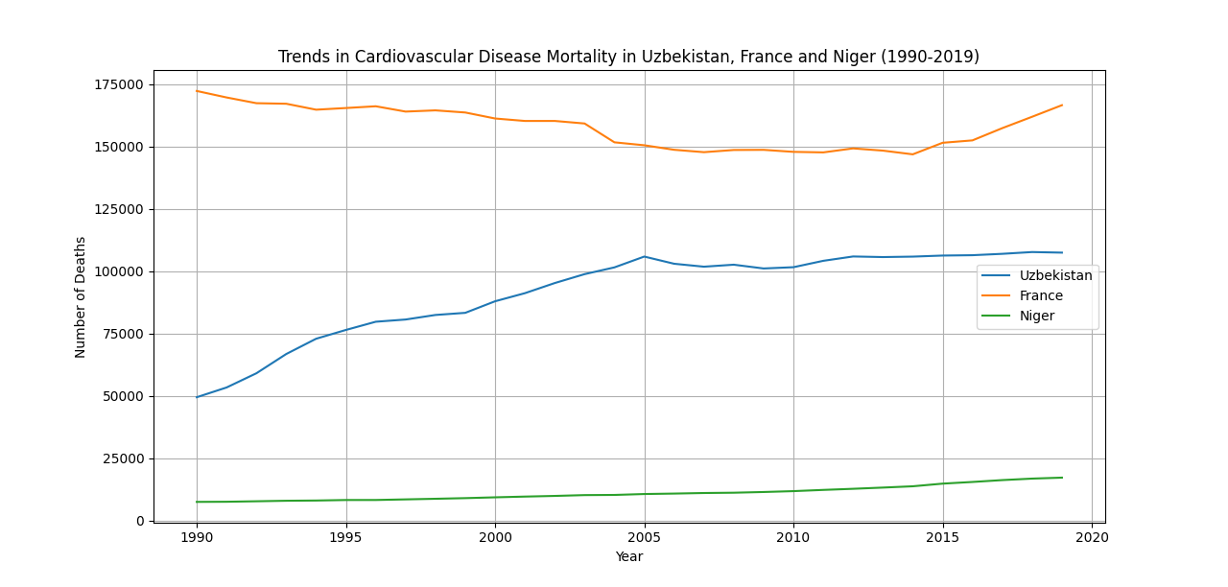
Even though the disease was more common in Uzbekistan than other types of diseases, it was still significantly lower when compared with its European counterpart, especially having a large difference during 1990s. Niger, at the same time, showed the lowest figure for the disease, meaning that probably some other diseases dominate the area rather than heart attacks or kidneys.
Conclusion
Even though the analysis may contain some errors, the purpose was to show the analysis methods used and how the analysis was conducted step by step. Regarding the key findings, cardiovascular diseases have been causing massive deaths in the country compared with other types of causes. However, this factor of death was even significantly higher in France even though it is yet unknown which specific factor is really responsible for more deaths in that country. The comparative analysis would have been even more insightful with more countries and types of diseases included compared, which is left for further analysis.
Links for sources:
https://www.kaggle.com/datasets/ivanchvez/causes-of-death-our-world-in-data
https://github.com/asadkozibaev/Mortality-rate-profile-of-Uzbekistan’

